“Київський фаховий коледж зв’язку”

Циклова комісія Комп’ютерної інженерії

**ЗВІТ ПО ВИКОНАННЮ**

**ЛАБОРАТОРНОЇ РОБОТИ №8**

з дисципліни: «Операційні системи»

**Тема: «Збереження службових даних системи та її мережева конфігурація»**

Виконавли студенти

групи РПЗ-03

Команда: Губенко Є.О.,

Заїка С.В. та Кресан Р.А.

Перевірив викладач

Сушанова В.С.

Київ 2022

**Мета роботи:**

1. Отримання практичних навиків роботи з командною оболонкою Bash.
2. Знайомство з базовими структурами для збереження системних даних - процеси, память, лог-файли та повідомлення про стан ядра.
3. Знайомство зі стандартом FHS.
4. Знайомство з діями при налаштуванні мережі.

**Матеріальне забезпечення занять**

1. ЕОМ типу IBM PC.
2. ОС сімейства Windows (Windows 7).
3. Віртуальна машина – Virtual Box (Oracle).
4. Операційна система GNU/Linux – CentOS.
5. Сайт мережевої академії Cisco netacad.com та його онлайн курси по Linux

**Завдання для попередньої підготовки**

***Готував матеріал студент Заїка С. В.***

1. На базі розглянутого матеріалу дайте відповіді на наступні питання:
   1. Розкрийте поняття “псевдо файлової системи”, для чого воно потрібно системі?

*A pseudo-file system (PFS) is a virtual file system that does not contain any physical devices, but behaves like a file system to allow users and programs to access the various system resources they need to operate.*

*A pseudo-file system is not an actual file system because it does not store data on disk, but is a collection of files and directories that are available within the operating system. It provides a way to access system resources such as processes, system statistics, sockets, system information, and other resources.*

*Pseudo-file systems are used in operating systems to provide access to various system resources, including process status, system statistics, network resources, and others. These resources are not stored in the file system, but can be accessed through a pseudo-file system.*

*Examples of pseudo-file systems are procfs and sysfs in Linux, which provide access to process and system information, respectively. In addition, Windows has pseudo-file systems, such as the Registry and Win32 API, which allow access to system information and configuration.*

* 1. Чому користувачі не так часто звертаються на пряму до каталогу /proc, яким чином з нього можна отримати інформацію?

*The /proc directory contains information about processes running on the system, as well as other system parameters. However, users usually do not access this directory directly, as its contents can be difficult to understand and process without using special programs or commands.*

*To get information from the /proc directory, you can use various terminal commands or programs. For example, the "ps" command displays a list of processes running on the system using the data contained in the /proc directory. In addition, other commands such as "top", "vmstat", "netstat", etc. can be used to retrieve information from different sections of the /proc directory.*

*So, although users do not directly access the /proc directory, they can still get information from this directory using various terminal commands or programs.*

* 1. Яке призначення файлів /proc/cmdline, /proc/meminfo та /proc/modules?

*The /proc/cmdline, /proc/meminfo, and /proc/modules files are part of the /proc directory on a Linux system and have the following purposes:*

*1. The /proc/cmdline file contains the kernel parameters that were transferred at system startup. This file allows users and system administrators to check the kernel configuration used by the system and change it by editing this file.*

*2. The /proc/meminfo file contains information about the system's memory usage. This file allows users and system administrators to get information about the total amount of memory, free and occupied memory, and other parameters related to memory usage.*

*3. The /proc/modules file contains a list of loaded kernel modules. This file allows users and system administrators to check which kernel modules are already loaded on the system and use this information to diagnose and solve problems.*

*In summary, /proc/cmdline, /proc/meminfo, and /proc/modules are important system files that allow users and system administrators to obtain important information about the system's configuration and resource usage.*

* 1. Яке призначення команди free?

*The free command is used in Linux to display information about the use of RAM and swap space on the system. It allows users and system administrators to check the amount of free and occupied memory, as well as the total amount of memory installed in the system.*

*The free command displays information in the form of a table with the following columns:*

* *total - the total amount of RAM and disk space in the system;*
* *used - the amount of used RAM and disk space;*
* *free - the amount of free RAM and disk space;*
* *shared - the amount of shared memory used by different processes;*
* *buff/cache - the amount of memory used for data buffering;*
* *available - the amount of available memory that can be used to start new processes.*

*The free command also allows you to display information about memory usage in other units, such as kilobytes, megabytes, or gigabytes. In addition, you can use the free command to display information about memory usage in real time.*

*Thus, the free command is an important tool for monitoring memory usage in a Linux system and allows users and system administrators to detect memory problems in time and use its resources more efficiently.*

* 1. Для чого потрібні лог-файли, наведіть приклади їх застосування?

*Log files are used to store information about events that occur in the system. These files can be used for various purposes, including the following:*

*1. Diagnosing problems: Log files can help system administrators find and resolve system problems, for example, by tracking errors that occur when programs or processes run, determining when operations are performed, and tracking interactions between different programs and services.*

*2. Process monitoring: Log files can help you monitor the performance of processes on your system, including determining their execution time, memory usage, and other parameters.*

*3. Auditing: Log files can be used to store data on user activity in the system, allowing system administrators to track who interacted with the system and when, what operations were performed, etc.*

*4. Performance analysis: Log files can help in analyzing system performance by determining the time of operations and other parameters, which allows you to find ways to improve system efficiency.*

*Examples of log files are:*

*- syslog: a log file that contains information about system events that occur on a Linux system;*

*- access.log: a log file that contains information about requests to the web server;*

*- error.log: a log file that contains information about errors that occur in programs or on the web server;*

*- auth.log: a log file containing information about user authorization in the system.*

*These log files can be analyzed using special tools, for example, log monitoring programs such as Logwatch, Logrotate, or using various command line tools such as grep, awk, sed, or programming languages such as Python or Perl.*

*In general, log files are important for maintaining system reliability and security, as well as for analyzing system performance and improving performance.*

* 1. Яке призначення файлу /var/log/dmesg?

*The /var/log/dmesg file contains the output of the operating system kernel when it starts. When the operating system begins to boot, the kernel outputs a lot of information about hardware configuration, device and driver definitions, and other system messages.*

*The /var/log/dmesg file allows users and administrators to view this kernel output if there are problems with hardware or drivers during system startup. The file can also be useful for determining the cause of device malfunctions.*

*This file is a text file and is usually located in /var/log/dmesg. Some Linux distributions automatically truncate the /var/log/dmesg file to prevent it from becoming too large, so it is important to review it immediately after starting the system to avoid missing useful information.*

* 1. Для чого розроблено FHS?

*The Filesystem Hierarchy Standard (FHS) is a standard that describes the structure of directories and files in Unix and Unix-like operating systems. It was developed to standardize the organization of the file system in Unix-based systems and to simplify the development, distribution, and management of software for these systems.*

*FHS defines the location of directories and files on a system, including the location of programs, libraries, configuration files, log files, temporary files, and more. Thanks to this standard, applications can be deployed more quickly and easily to different systems, administrators can find and manage different resources on a system more quickly, and developers can more accurately predict where different file resources are located on a system.*

*FHS is essential for ensuring the compatibility and portability of software on Unix and Unix-like systems. It also contributes to system security and reliability by allowing administrators to more accurately control access to various files and resources on the system.*

* 1. Які основні команди є у Linux для перегляду та конфігурації мережі

*Linux has several commands that can be used to view and configure the network. The most common of them are:*

*- ifconfig - a command that displays information about the status of network interfaces (IP address, netmask, connection status, etc.).*

*- ip is a more modern alternative to ifconfig. It allows you to view information about network interfaces, routing, ARP table, and other network parameters.*

*- route - a command that displays information about the routing table in the system.*

*- ping - a command that sends packets to the specified IP address and displays statistics on data transmission and response time.*

*- traceroute - a command that allows you to track the path that packets take on the way to the specified IP address.*

*- nslookup - a command that allows you to perform DNS queries and check the correspondence between domain names and IP addresses.*

*- netstat is a command that displays information about the status of network connections, open ports, and other network parameters.*

*- ss is a more modern alternative to netstat. Allows you to display information about the status of network connections and other network parameters.*

*- iptables - a command for configuring a firewall in Linux.*

*- hostname - a command that allows you to view and change the host name in the system.*

*These commands can be useful for network administration and diagnosing network problems. To use some of them, you may need to have superuser rights (root).*

**Хід роботи**

***Готував матеріал студент Губенко Є.О***

1. Опрацюйте всі приклади команд, що представлені у лабораторних роботах курсу NDG Linux Essentials - Lab 13: Where Data is Stored та Lab 14: Network Configuration. Створіть таблицю для опису цих команд***.

|  |  |
| --- | --- |
| **Назва команди** | **Її призначення та функціональність** |
| su | change the current user to root |
| ls /proc | view the contents of the /proc system directory (this requires root access rights) |
| cat /proc/1/cmdline; echo | prints the command line arguments (using /proc) for the process with ID 1, which is the system initialization process. The delimiter echo is used to break the line so that the result is printed on a separate line. |
| ps -p 1 | returns information about the process with identifier 1, which is the system initialization process |
| cat /proc/cmdline | displays command line arguments (using /proc) for the current kernel |
| ping localhost > /dev/null | sends packets to the localhost using ping and redirects the output to /dev/null, which leads to no output on the screen |
| ping localhost > /dev/null & | starts ping in the background (with &), which allows you to continue executing other commands while ping continues to run in the background. |
| jobs | displays a list of active background tasks running in the current shell. |
| fg %1 | re-activates the task that is in the foreground with the identifier 1 (using %1), that is, moves it to the foreground of the terminal |
| bg %1 | puts the task with ID 1 (using %1) in the background if it was previously active in the foreground. |
| kill %3 | sends a signal to stop the background task with identifier 3, which was started in the background using &. |
| killall ping | sends a signal to stop all processes named ping. |
| top | shows a list of active processes and their characteristics in real time. |
| sleep 888888 & | runs the sleep command in the background, which causes the shell to stop for 888888 seconds (about 10 days). |
| kill PID | sends a signal to stop the process with the specified identifier (PID). |
| pkill -15 sleep | sends a SIGTERM signal to stop all processes named sleep. |
| ps -e | displays a list of all processes in the system. |
| ps | displays a list of processes running in the current shell. |
| ps -o pid,tty,time,%cpu,cmd | displays information about all processes running in the current shell in a format that includes the process PID, terminal, execution time, CPU usage percentage, and the command the process is executing. |
| ps -o pid,tty,time,%mem,cmd --sort %mem | displays information about all processes running in the current shell in a format that includes the process PID, terminal, execution time, percentage of memory usage, and the command the process is executing. Processes are sorted by percentage of memory usage. |
| Free | shows information about free and used memory in the system. |
| ls /var/log | displays a list of system log files stored in the /var/log directory. |
| ssh localhost  {At the first prompt, type yes}  {At the second prompt, type abc}  {At the third prompt, type abc}  {At the fourth prompt, type abc}  tail -5 /var/log/auth.log | ssh localhost: This command establishes an SSH connection to a local machine.  {At the first prompt, type yes} {At the second prompt, type abc} {At the third prompt, type abc} {At the fourth prompt, type abc}: these commands enter responses to SSH server requests for user identification and password confirmation.  tail -5 /var/log/auth.log: this command displays the last 5 lines of the system authorization log saved in the file /var/log/auth.log. |
| Route | displays the network routing table. It shows the paths that packets take between network interfaces and routers. |
| grep 127.0.0.1 /etc/hosts | is designed to search for text in the specified files or output, and returns all lines that contain the specified pattern. |
| ping -c4 localhost | is used to check the availability and response time of a computer on the network. |
| cat /etc/resolv.conf | shows the configuration of DNS servers on the computer. |
| dig | is used to obtain information about DNS records. |
| Netstat | is used to check network connections, open ports, and network packet routing. The command can be used to check network activity, which includes a list of open ports and active network connections. |
| start_webserver | can be used to run a web server on a local computer. |
| ss | is used to display network connections, open ports, and other network statistics that can help diagnose network problems. |

***Готував матеріал студент Кресан Руслан***

1. Виконайте практичні завдання у терміналі (продемонструйте скріншоти):

* **в даній лабораторній роботі використовувалась команда cat, дослідіть її можливості та опишіть для яких задач вона призначена;**

*The cat command in Linux is one of the most widely used and powerful commands for outputting and merging text files. It allows you to display the contents of a file on the screen using the built-in text editor that performs this operation. In addition, cat can merge two or more files into a single file or output them to the console.*

*The main options for using the cat command are as follows:*

* *Displaying the contents of a file on the screen:*

*cat file.txt*

* *Merge two or more files:*

*cat file1.txt file2.txt > merged_file.txt*

* *Display the contents of multiple files on the screen:*

*cat file1.txt file2.txt file3.txt*

* *Add file content to the end of another file:*

*cat file1.txt >> file2.txt*

* *Create a new file and enter content from the console:*

*cat > newfile.txt*

* **продемонструйте приклади, коли команда cat використовується для створення файлу, перегляду вмісту файлу, перенаправлення інформації у інший файл, склеювання декількох файлів в один;**

*To create a new file, you can use the cat command and direct its output to a new file.*

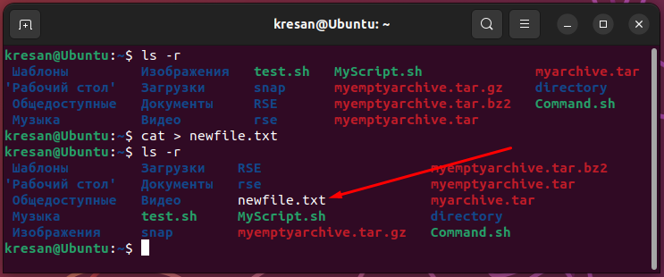

*To view the contents of a text file, use the cat command. To do this, in the text file we created, we write the name of the laboratory work "Laboratory work №8", then use the cat command to view the contents of the file.*

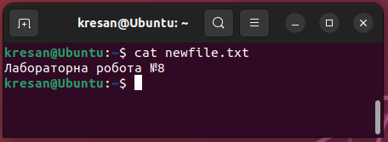

*To redirect the contents of a file from one file to another, you can use the cat command in combination with the output redirection statement >.*

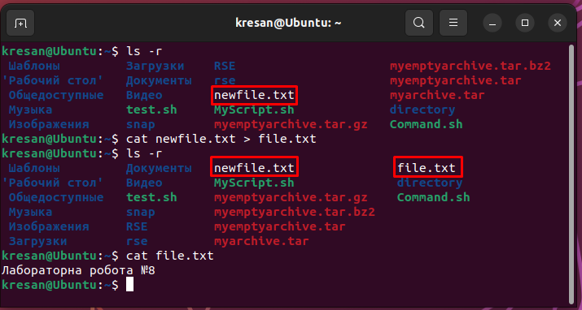

*To merge multiple files into one, you can use the cat command and the output redirection statement >.*

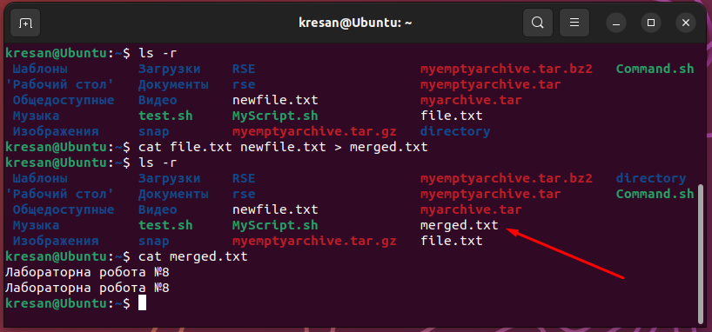

* **які параметри команди cat треба використати, щоб пронумерувати рядки файлу, відобразити недруковані символи, видалити порожні рядки?**

*You can use the -n or --number option to number the lines of a file. This command will display the contents of the file, numbering each line.*

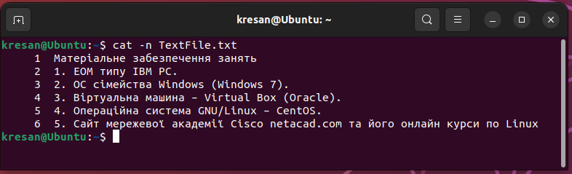

To display nonprinting characters, you can use the -v or --show-nonprinting option.

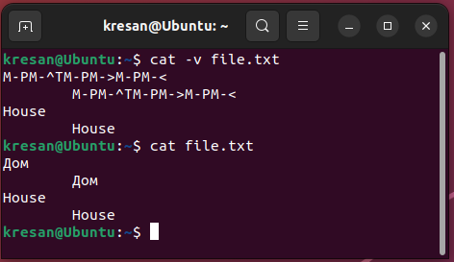

*When displaying the contents of a file with the cat command, the console uses an encoding that may not support Cyrillic. Therefore, Cyrillic characters are displayed as byte sequences represented in the format M-PM-^TM-PM->M-PM-<.*

*When you use the -v option of the cat command, these byte sequences are displayed as control characters, which allows you to distinguish them from normal characters. In my case, "House" is displayed as M-PM-^TM-PM->M-PM-< because it contains a tab and a newline as control characters. And the word House is displayed normally because it contains only the regular characters of the Latin alphabet.*

*To remove empty strings, you can use a combination of cat and grep commands.*

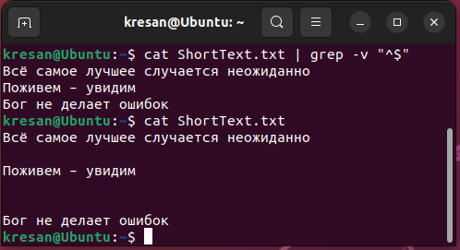

*This command displays the contents of a file, excluding blank lines. Explanation: the grep command is used to search for strings that match a specific pattern, -v excludes strings that match the pattern, and "^$" is a pattern for selecting empty strings.*

* **опишіть можливості команди dig та наведіть приклади;**

*The dig command is a utility for obtaining information about DNS records and for performing DNS queries. Typically, this command is used to check the operation of a DNS server and to diagnose DNS queries.*

*Some of the features of the dig command are:*

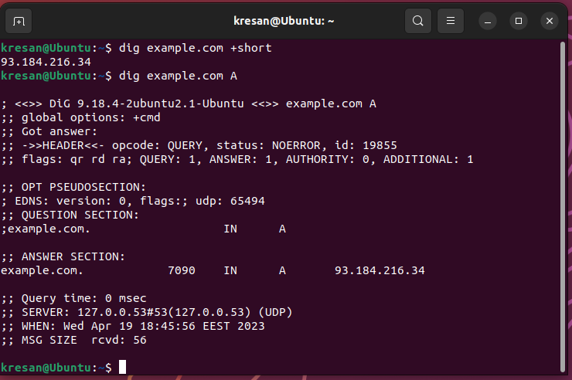

* **опишіть можливості команди netstat та наведіть приклади;**

*The netstat command is a command-line utility that displays statistics about network connections on your computer. It allows you to view information about network interfaces, open ports, connections, routing, and other network parameters.*

*To run the netstat command, you need to install the net-tools package, which contains the netstat utility.*

*Some features of the netstat command:*

*Displays a list of open ports and processes using those ports:*

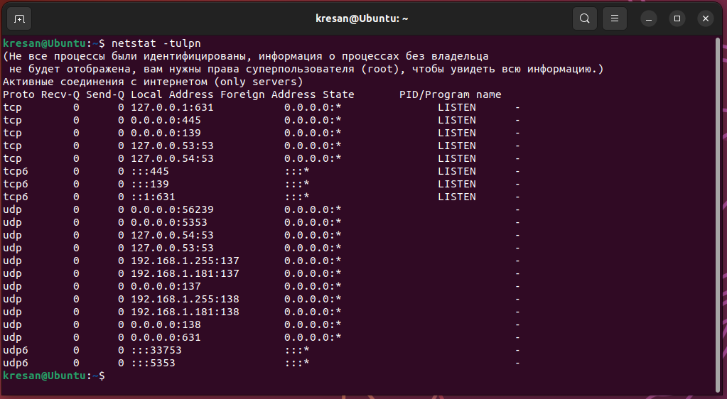

*Displaying the routing table:*

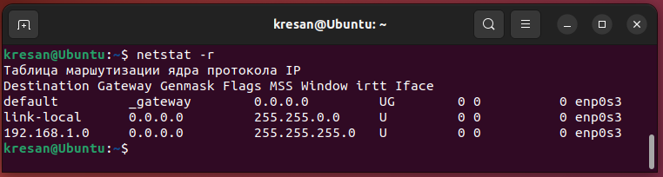

*Display a list of active network connections:*

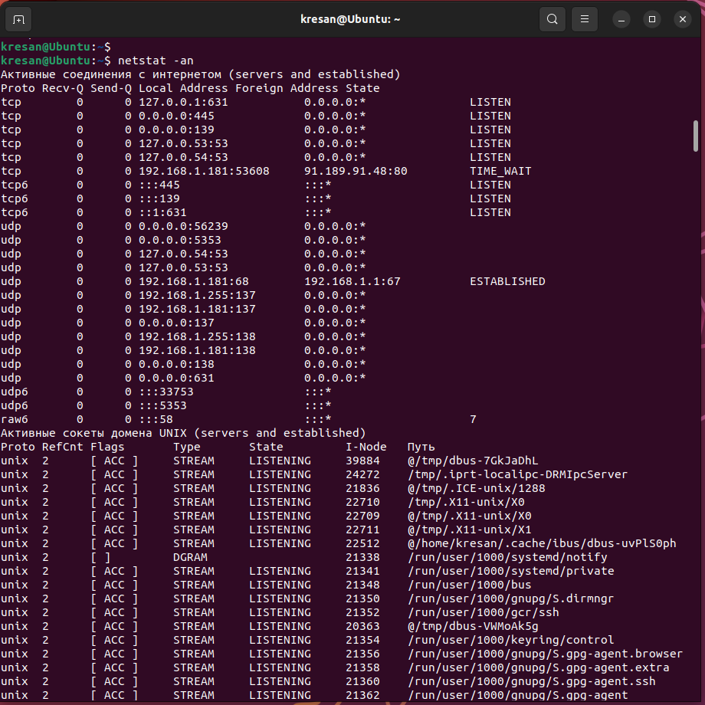

***Готував матеріал студент Заїка С. В.***

**Відповіді на контрольні запитання**

1. Як пов’язані між собою команди cat та tac?

*The cat and tac commands are both commands for working with files in Linux, but they have different functions.*

*The cat (or "concatenate") command is used to output the contents of a file to a standard output stream. For example, the cat file.txt command will output the contents of the file file.txt to the terminal.*

*The tac (or "reverse concatenate") command is used to output the contents of a file in reverse order.*

*Thus, the cat and tac commands are opposite of each other, because cat prints the contents of a file in forward order, while tac prints them in reverse order. To use these commands, you need to specify the name of the file you want to display (cat file.txt or tac file.txt).*

1. Що робить команда ss?

*The ss command (short for "socket statistics") is used to display network socket statistics in Linux. It allows you to view open network ports, network connections, routes, network interfaces, and other information about the system's network activity.*

*Some of the main options of the ss command are:*

*-t, -u, -w: display statistics for TCP, UDP, and RAW sockets, respectively;*

*-a: show all connections, including active and inactive;*

*-n: display statistics in numerical format instead of displaying host and service names;*

*-p: show information about processes that use network ports;*

*-r: show routing information;*

*-i: display statistics for network interfaces.*

*For example, the ss -t -a command displays all TCP connections, including active and inactive ones, and the ss -i command displays statistics for network interfaces.*

*The ss command is a powerful tool for diagnosing network problems, monitoring network activity, and performing administrative tasks related to network settings.*

1. В чому відмінність між командами ps --forest та pstree?

*The ps --forest and pstree commands are used to display processes in a process tree.*

*The main difference between these commands is that ps --forest is an option of the ps command, while pstree is a separate command. In addition, ps --forest typically provides more detailed information about each process in the form of a table listing the processes and their children, allowing you to track dependencies between processes.*

*pstree, on the other hand, is easier to use and has a more intuitive process tree display format. It displays all processes as a tree with the root at the initialization process (PID 1).*

*So, if you need to get more detailed information about processes, their dependencies and parameters, you should use ps --forest. And if the main goal is to visualize the process tree with a simplified display format, it is better to use pstree.*

1. У яких каталогах зберігаються налаштування системи?

*On Linux, system settings are stored in different directories. The main ones are:*

*/etc is the main directory for system and program configuration files. It contains settings for various services, such as networking, printing, security, firewall, and others.*

*/usr - this directory contains additional programs and configuration files that are not necessary for the basic operation of the system. For example, the configuration of the browser, text editors, and other applications is stored here.*

*/var - this directory contains variable data that can change during system operation. It contains logs, cached files, databases, temporary files, etc.*

*/root - this is the home directory of the root user.*

*/home - this directory contains the home directories of users.*

*/boot - this directory contains the files needed to boot the system.*

*/opt - This directory contains additional programs that can be installed separately from the base system.*

*/proc - this directory is a virtual file system that contains information about running processes, memory, network connections, and other information provided by the system kernel.*

*Depending on the distribution and system settings, there may be other directories that are used to store configuration files and other data.*

1. У яких каталогах можна знайти встановлені в системі програми, доступні для користувача?

*On Linux, programs are usually installed in certain standardized directories so that users can easily find and run them. The main directories where installed programs are usually stored are:*

*/usr/bin - this directory contains most of the installed programs for ordinary users.*

*/usr/sbin - this directory usually contains installed system programs that are available to the system administrator.*

*/usr/local/bin - this is the directory for user-installed programs that are not included in the standard Linux distribution.*

*/usr/local/sbin - this directory usually contains system programs installed by the user that are not included in the standard Linux distribution.*

*/bin - this directory contains the basic programs that are needed for the system to work, such as ls, cp, rm, etc.*

*/sbin - this directory contains system programs that are not available to ordinary users, but only to system administrators.*

*/opt - this directory contains installed programs that are not included in the standard Linux distribution, but were specially developed for this operating system.*

*Depending on the system configuration, some programs may be installed in other directories, so you should check the distribution documentation for complete information about the directories where the installed programs are stored.*

1. У яких каталогах можна знайти встановлені системні програми і програми призначені для виконання суперкористувачем?

*On Linux systems, installed system programs and programs available only to the superuser are stored in several directories:*

*/bin: this directory contains executable files of basic commands required for the system to work in single-user mode.*

*/sbin: This directory contains executable files of system commands that require administrator rights to execute. For example, commands for configuring the network, initialization system, etc.*

*/usr/sbin: This directory contains executable files of system commands that are usually used by system administrators.*

*/usr/local/sbin: This directory usually contains executables associated with additional software installed from sources other than the standard distribution repositories.*

*/usr/local/bin: this directory usually contains executable files of programs that are installed from sources other than the standard distribution repositories.*

*/usr/bin: This directory contains executable files of programs that are installed from the standard distribution repositories.*

*/usr/games: this directory contains the executable files of games.*

*/usr/share: This directory contains various system files, including data and configuration files for installed programs.*

*The specific list of directories may vary depending on the distribution and its configuration.*

1. Поясніть призначення команд ping, ifconfig, traceroute.

*The ping command is used to check network availability by sending signals to a specified IP address or domain name and waiting for a response from that address. It also indicates the time of sending and the time of receiving the response, which allows you to determine the ping (delay) of the network.*

*The ifconfig command is used to configure and display information about network interfaces, such as IP addresses, MAC addresses, netmasks, and other parameters. It is now replaced by the ip command, but is still available in most Linux distributions.*

*The traceroute command is used to trace the route of packets through a network. It allows you to identify all the network nodes (routers) that a packet passes through on its way to the endpoint and the time it takes to pass each node. This helps to identify network problems, such as network congestion, malfunctioning routers, etc.*

1. Як називаються мережеві інтерфейси в Linux?

*Network interfaces in Linux can have different names, depending on what hardware is used and what network driver is installed. The main names of network interfaces used in Linux are:*

*ethX - Ethernet network interfaces (X is the interface number, such as eth0, eth1, etc.).*

*wlanX - Wi-Fi network interfaces (X is the interface number, for example, wlan0, wlan1, etc.).*

*lo - local network interface used to access the local host (loopback).*

*pppX - PPP (Point-to-Point Protocol) network interfaces used to connect to the Internet via a modem.*

*These names may differ depending on the Linux distribution and network settings. Other types of network interfaces may have their own names, such as InfiniBand and Fibre Channel.*

1. Як за допомогою команди ifconfig вивести параметри тільки одного мережевого інтерфейсу (наприклад, eth1), а не всіх?

*In order to display the parameters of only one network interface using the ifconfig command, you need to specify its name after the command. For example, to display the parameters of the eth1 network interface, you need to enter the following command in the terminal:*

* + *ifconfig eth1*

*This command displays information about the eth1 network interface, including its IP address, subnet mask, MAC address, and other parameters.*

***Готував матеріал студент Кресан Руслан***

**Висновки**

During the laboratory work, we gained practical skills in working with the Bash command shell. We got acquainted with the basic structures for storing system data. We learned about the FHS standard and how to set up a network.